Unit testing practice

Unit testing is very important procedure in the project and must be used for all modules. It has two major advantages for us. The fist is improving quality of the application from the beginning of development. Correctly written unit tests, based on assumed logic for the component and based on the design, should guarantee that when we integrate independent modules into the bigger ones they will work almost perfectly. There will not be needed to precisely check all aspects of functionality of the final application. This will be done automatically with regression tracking. Another advantage is more related for developers. Using unit testing there is no need to integrate your component into the product and repeat annoying steps to check that your few lines of code work as expected and haven't broken the product. The only rule here is “keep your tests small and fast”.

For the FreeSCADA2 project we would like to have 80% code covered by unit tests and 100% tests passed before releasing new version for the community.

Examples of unit tests

Here are few code snippets to help writing tests. At this moment we have two unit test framework:
- Nunit (nunit.framework.dll) – should be used for non-visual components testing
- NunitForms (nunitforms.dll) – should be used for GUI elements testing and for assistance with testing of mixed “visual” and “non-visual” components.
To use these frameworks you should add reference to its assemblies. To run test, you could use “nunit.exe” application shipped with NUnit.
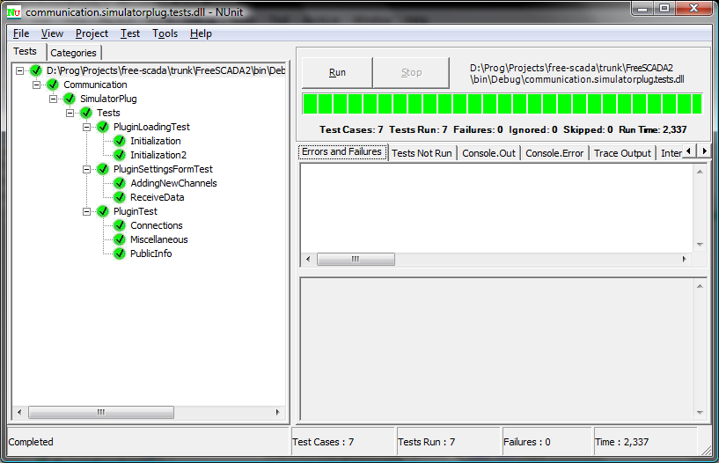
There is also possible to use integrated into SharpDevelop functionality.
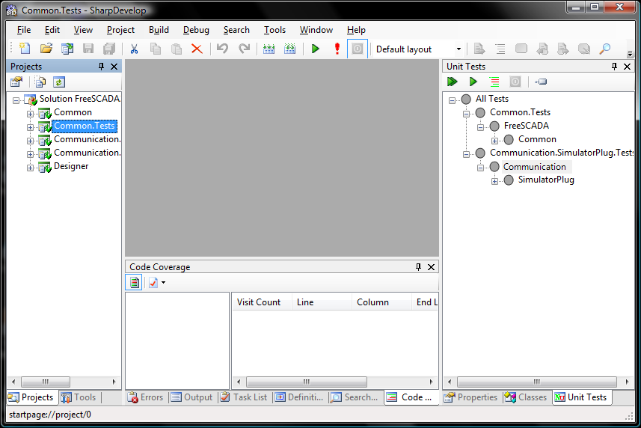

To collect code coverage statistic you can also use SharpDevelop:

This command will execute unit test and on “Code Coverage” panel you will see statistic:

Lets move on to specific examples:

Example 1:

using NUnit.Framework;

[TestFixture]
public class ProjectTest
{
[Test]
public void StreamContent()
{
Project p = new Project();
MemoryStream stream = p["test1"];
Assert.IsNotNull(stream);
Assert.IsTrue(stream.CanRead);
Assert.IsTrue(stream.CanWrite);
}
}

Please note that a test class should be public. To make this class visible for unit test framework use [TestFixture] attribute. Each test member should have [Test] attribute as well.

Example 2:

using NUnit.Framework;

[TestFixture]
public class ProjectTest
{
[SetUp]
public void Init()
{
}

[TearDown]
public void DeInit()
{
}
}

Functions Init() and DeInit() will be called before and after each test in the class.

Example 3:

using NUnit.Framework;
using NUnit.Extensions.Forms;

[TestFixture]
public class PluginSettingsFormTest : NUnitFormTest
{
public override void Setup()
{
//Called before a test
}

public override void TearDown()
{
//Called after a test
}

[Test]
public void AddingNewChannels()
{
ExpectModal("SettingsForm", "AddingNewChannelsHandler");
plugin.ProcessCommand(0); //This command opens a modal form
Assert.AreEqual(3, plugin.Channels.Length);
}

private void AddingNewChannelsHandler()
{
ButtonTester okButton = new ButtonTester("okButton", "SettingsForm");
okButton.Click();
}
}

Here is an example how to test modal forms. Arguments of ExpectModal() method are modal form name and method name which should be called for testing.

